**ANALYSING HOUSING PRICES IN METROPOLITAN**

**AREA OF INDIA**

**1 INTRODUCTION**

*1.1 OVER VIEW:*

Since the inception of the theory and idea of development, the common feature that

emerged in different point of time is the developmental gap that emerged in different

parts of the world and also among various parts of a country in a particular time period.

This disparity in development, like many other indicators, has also been reflected in

India. Traditional development theories believed that agriculture, industrialisation,

urbanisation, are significant ingredients of growth, and, ultimately important

prerequisites for achieving development.

***1.2 PURPOSE:***

Prediction house prices are expected to help people who plan to buy a house so they can know the price range in the future, then they can plan their finance well. In addition, house price predictions are also beneficial for property investors to know the trend of housing prices in a certain location.

**2.PROBLEM DEFINITION & DESIGN THINKING**

*2.1 EMPATHY MAP:*

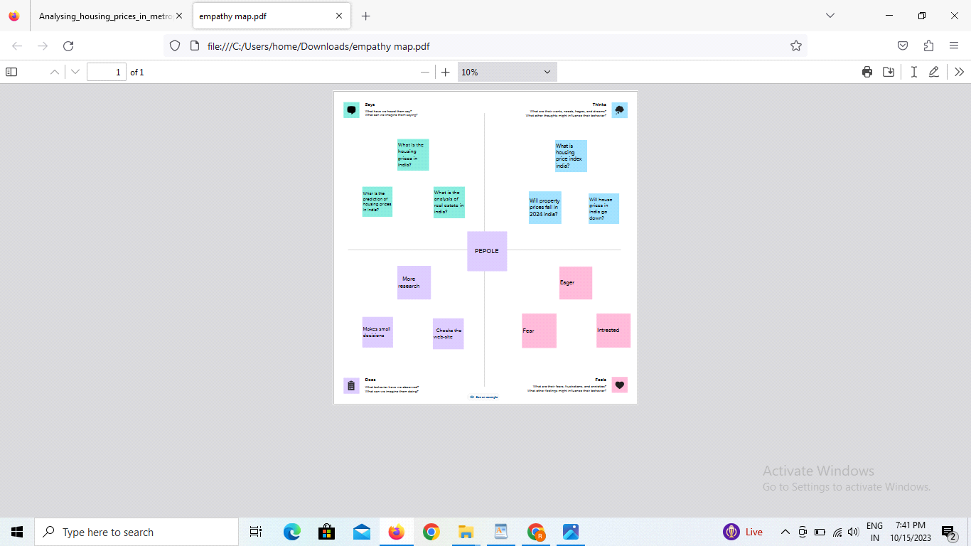

*2.2 IDEATION& BRAINSTROMING MAP:*

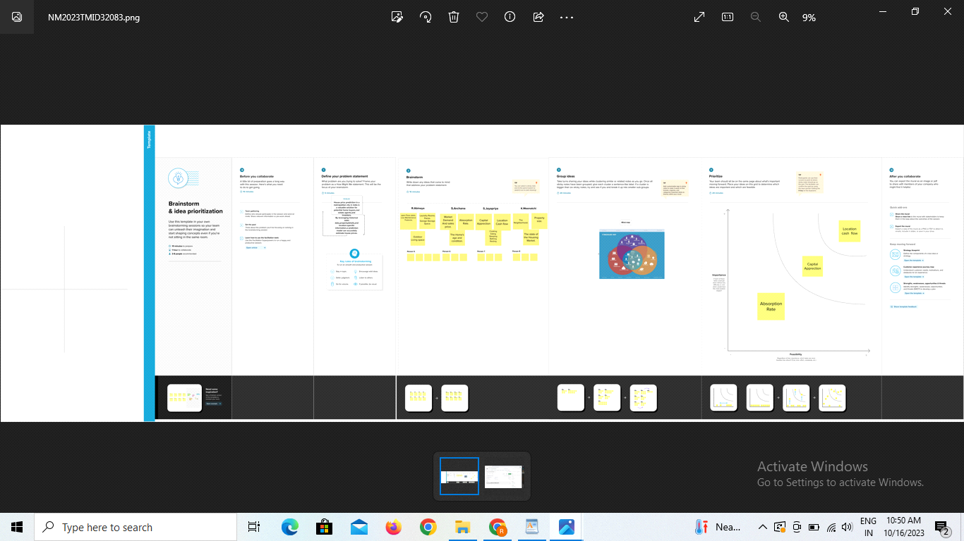

3.RESULT:

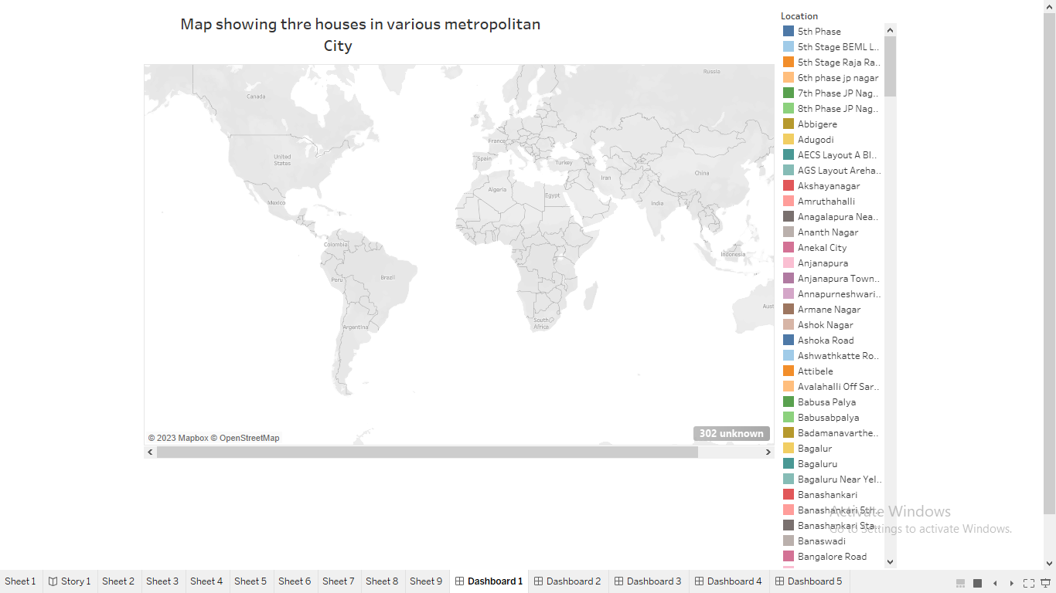

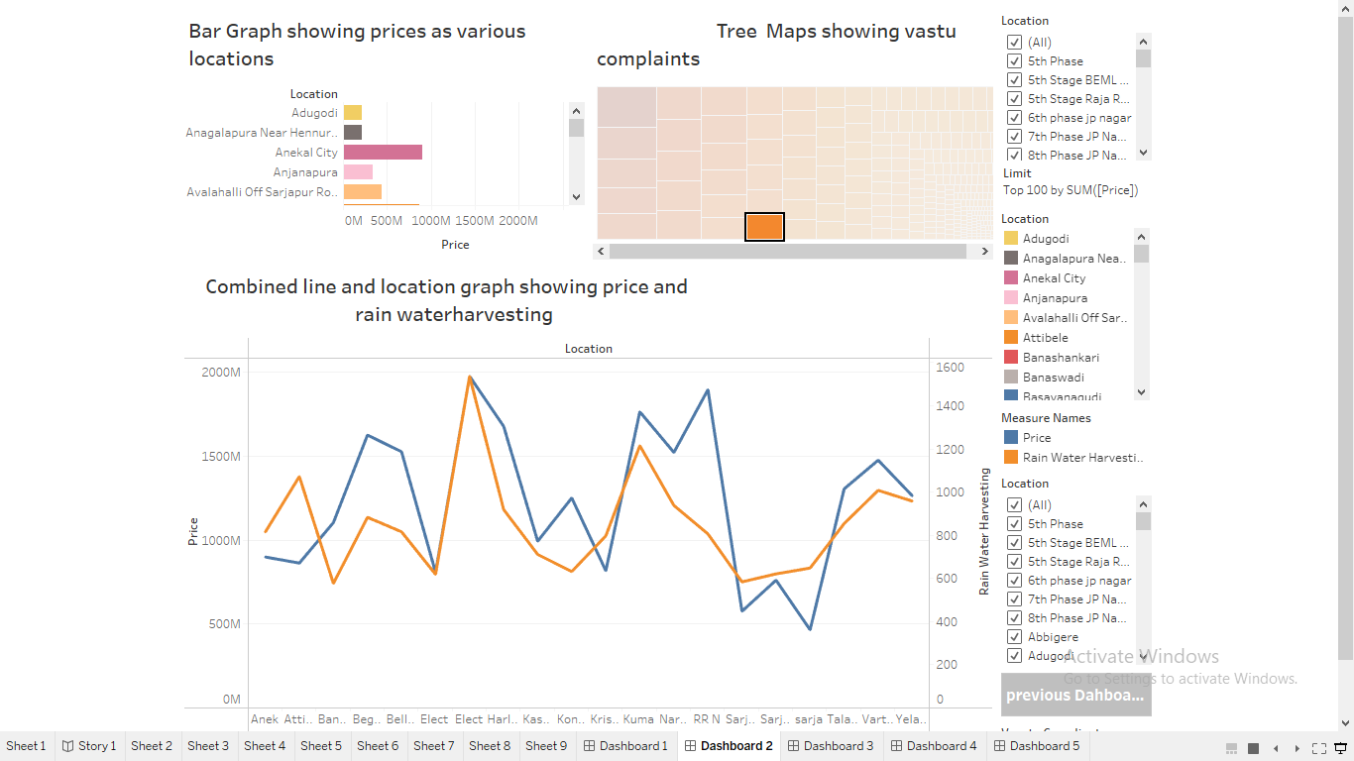

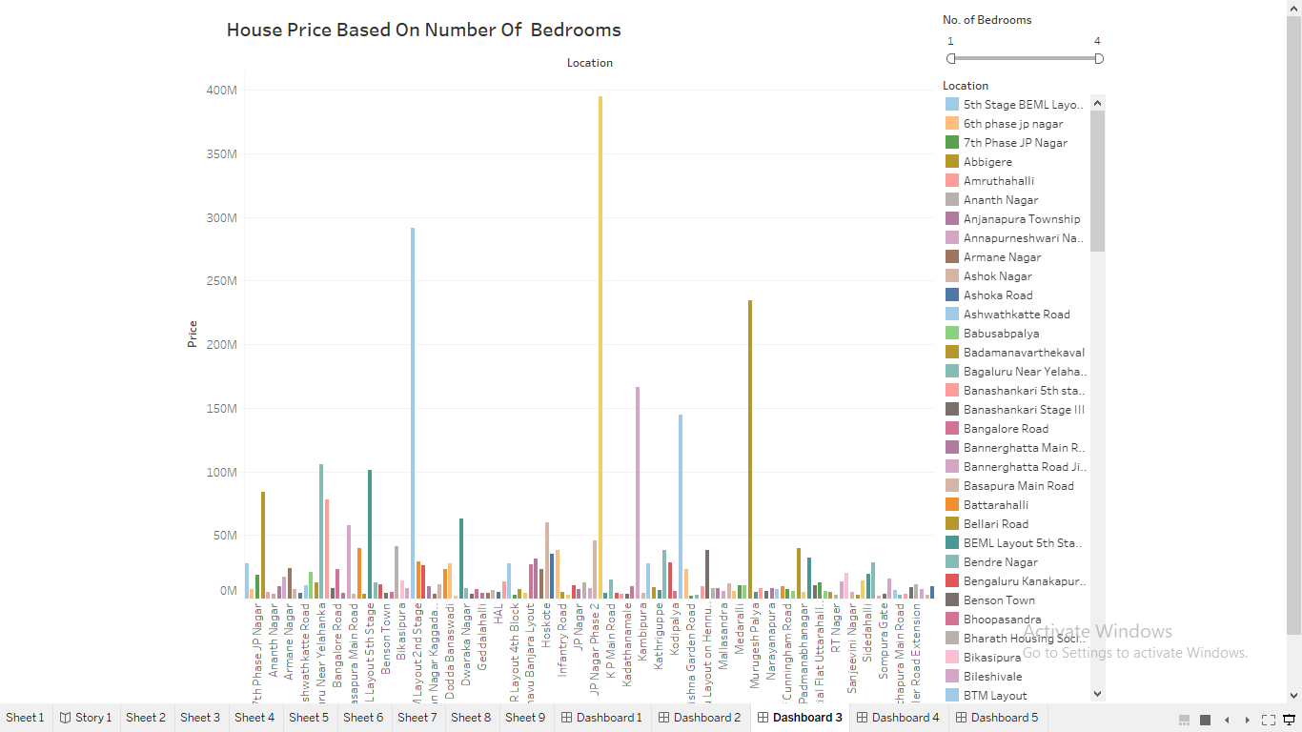

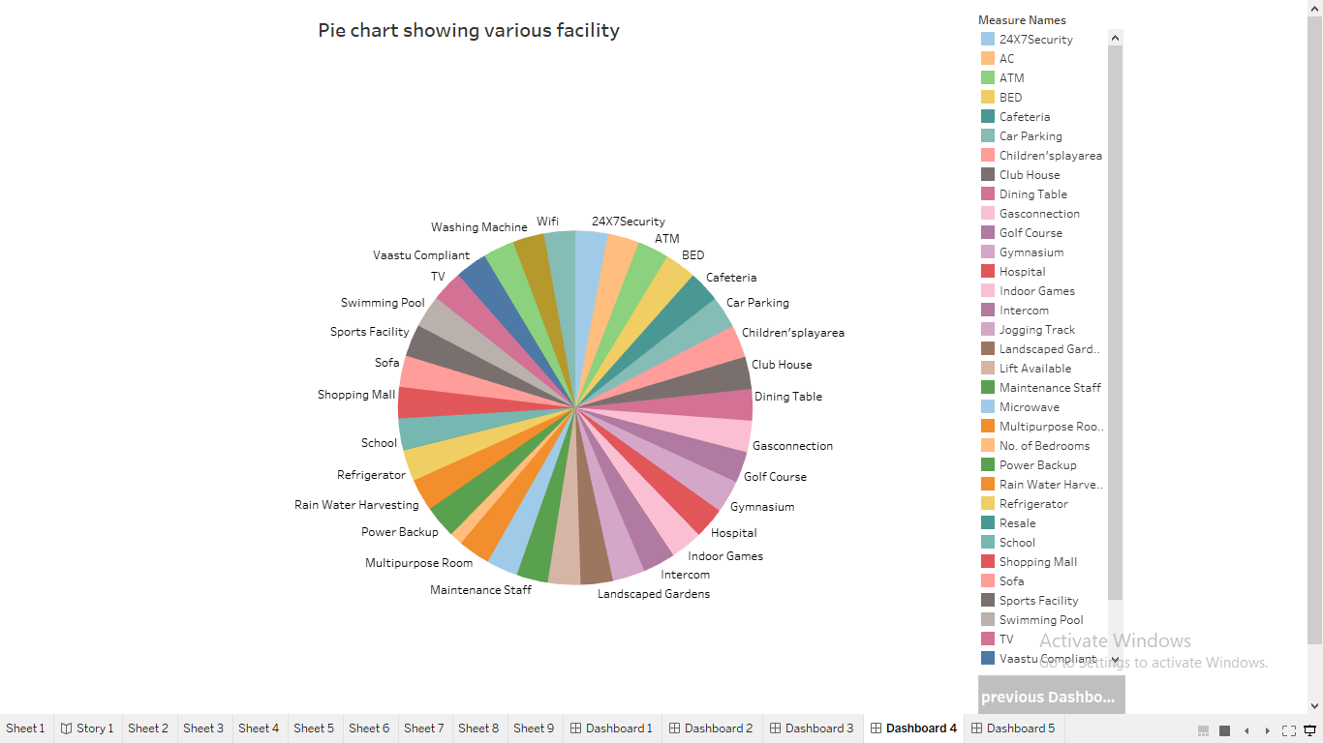

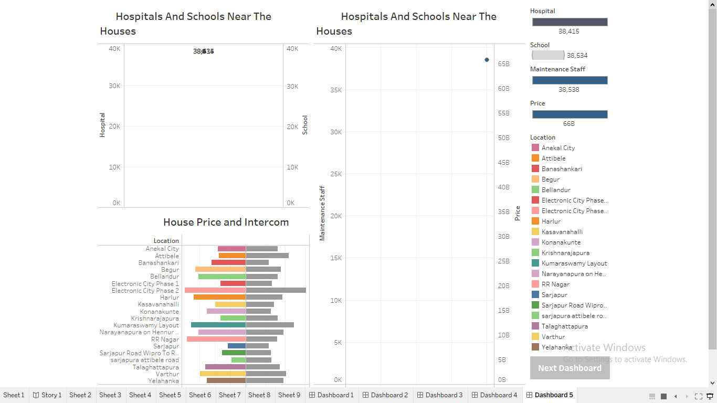

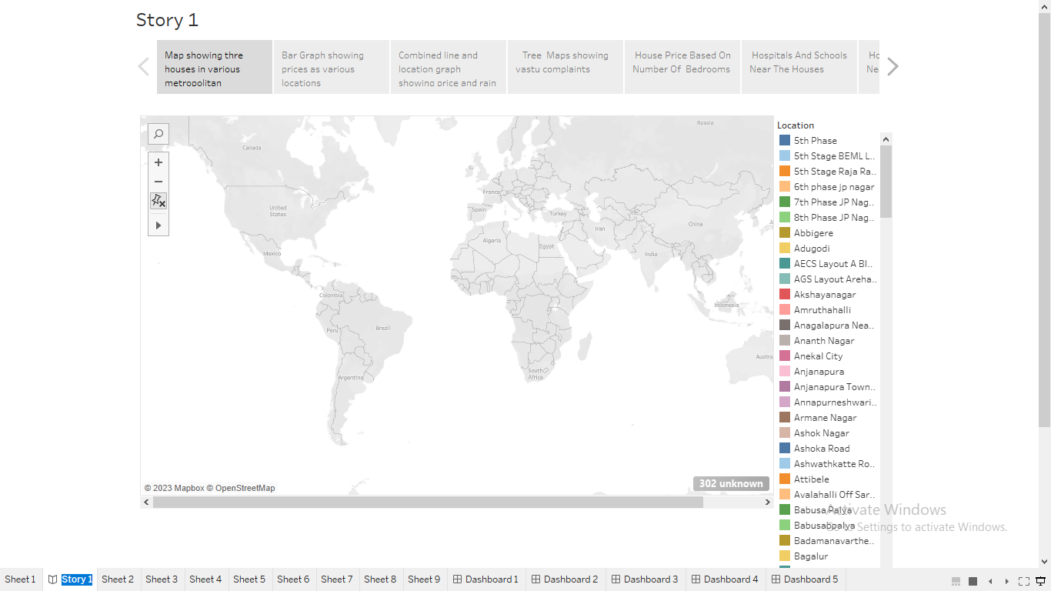

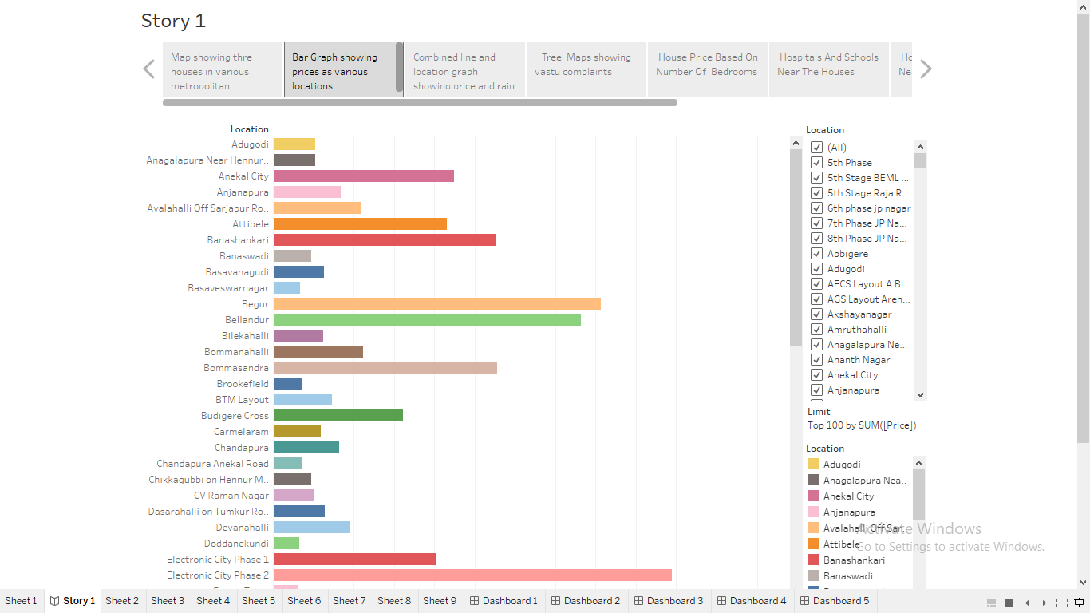

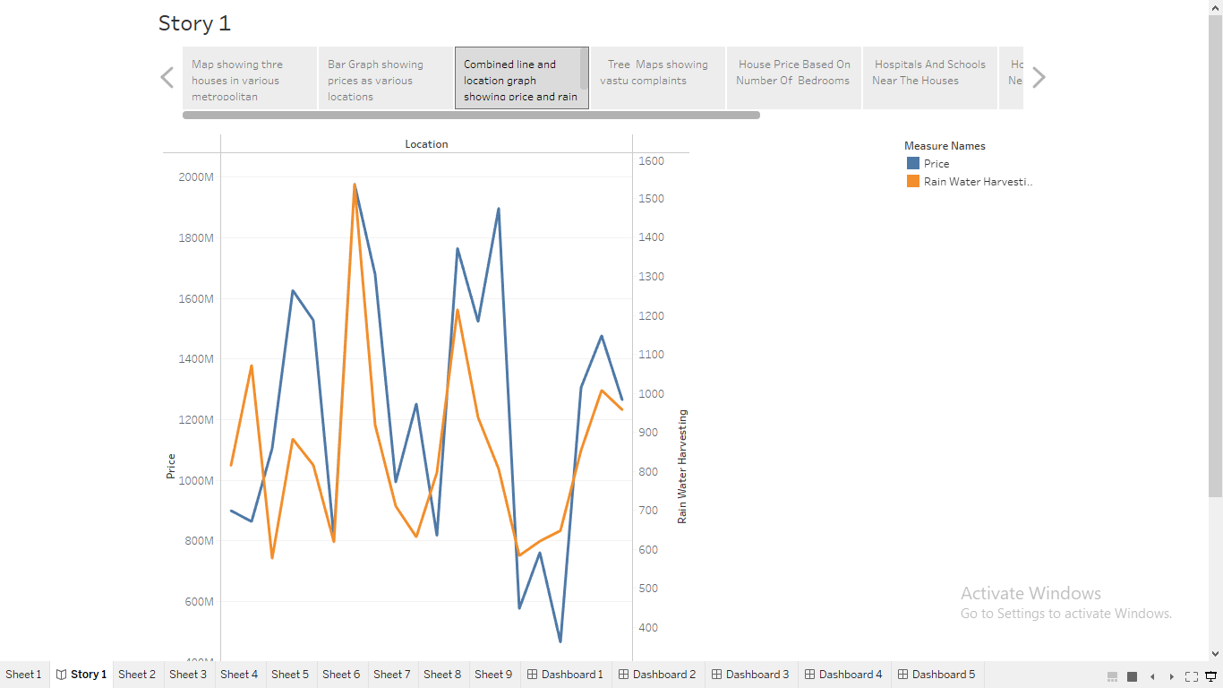

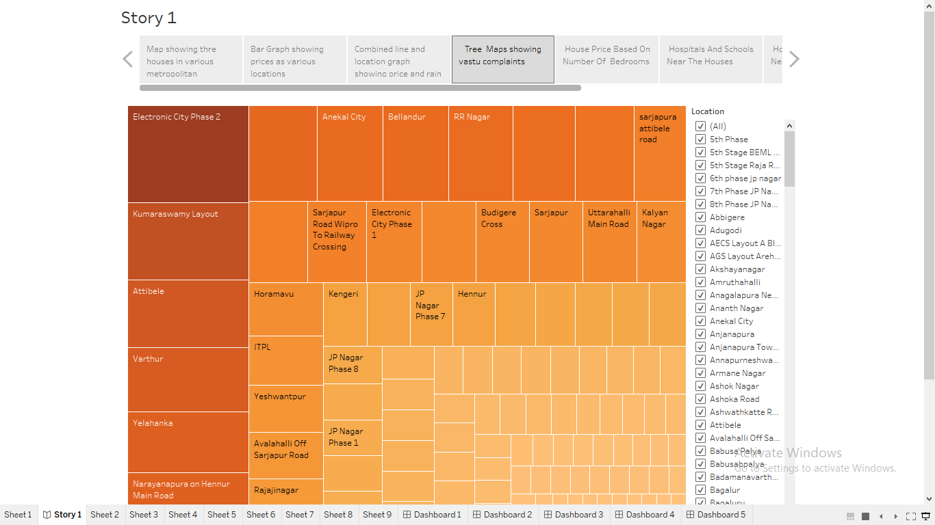

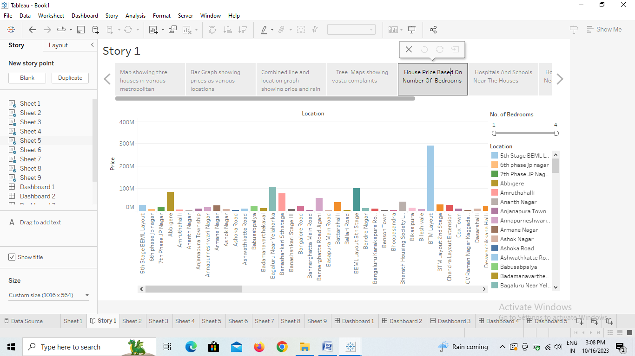

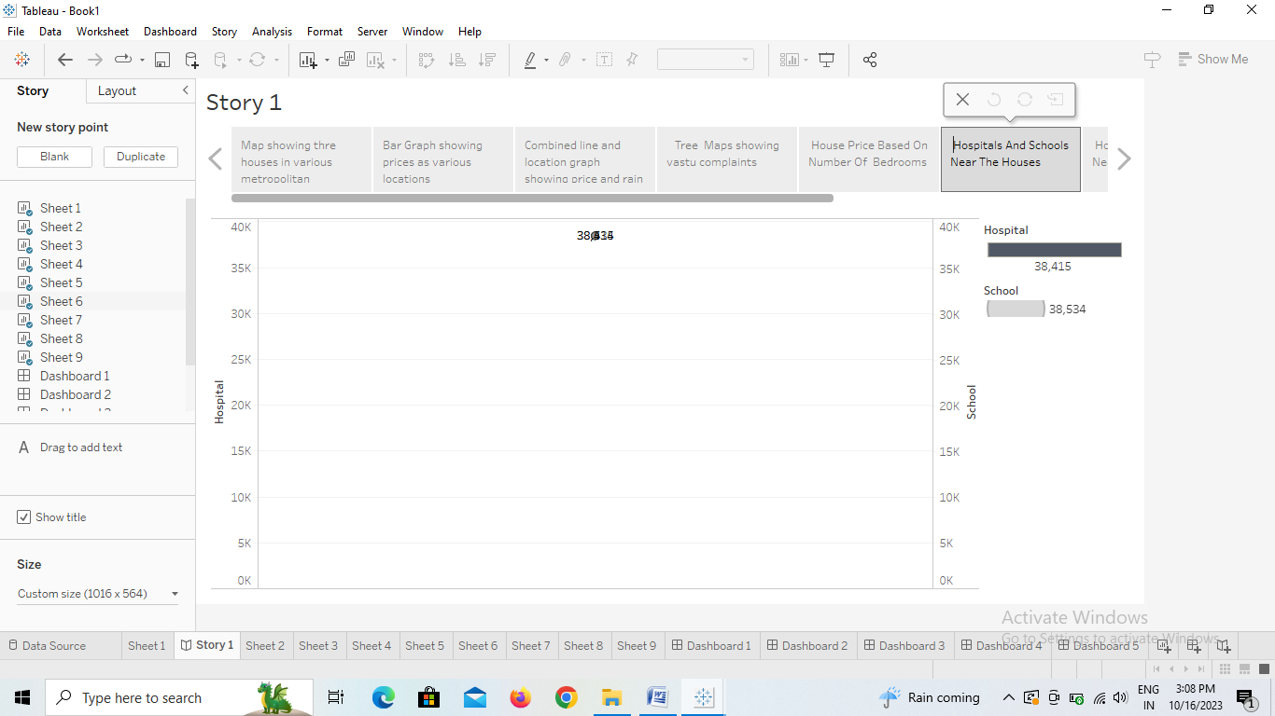

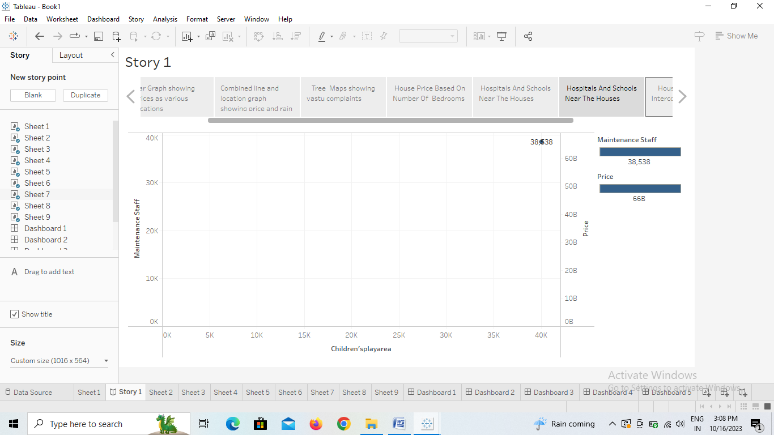

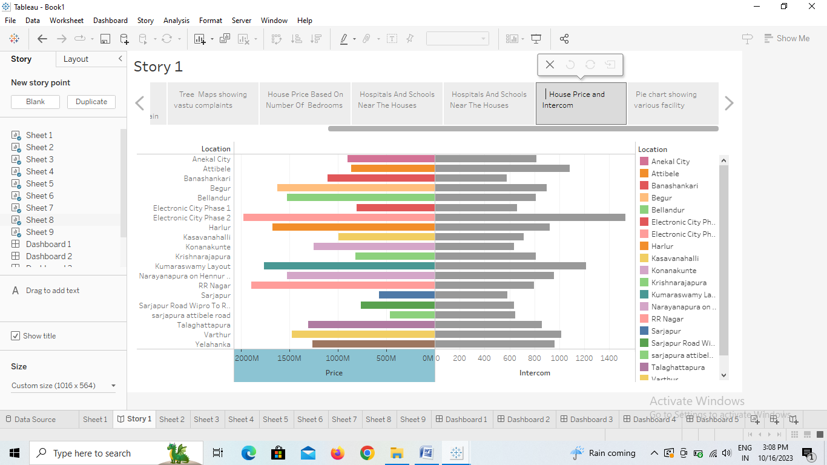

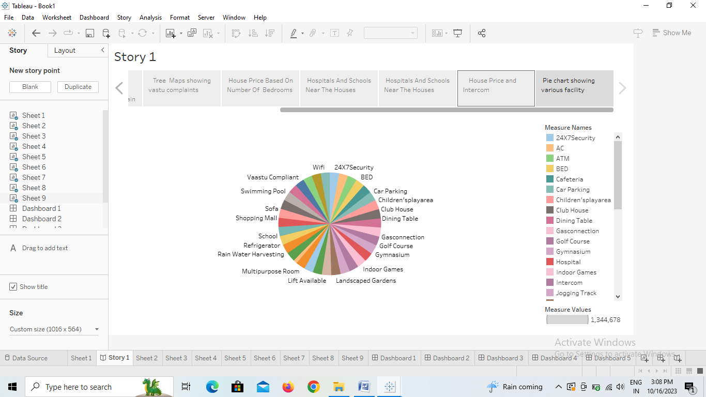

**4. ADVANTAGES AND DISADVANTAGES:**

*4.1 ADVANTAGES:*

* High-speed public transit system in the form of Metro/Monorail/Metrolite/RRTS/MRTS.
* High-speed internet access in the form of Fiber and 5G.
* One-day delivery of products including essentials like medicines and groceries.
* Facilities of doctor-at-home and ease of access of medical.
* Wide varieties of restaurants to order from.

*4.2 DISADVANTAGES*:

* High cost of rent and food.
* Overpopulation and pollution.
* Increased competition and societal callousness.

**5.APPLICATIONS**:

* House price prediction can help the developer determine the selling price of a house and can help the customer to arrange the right time to purchase a house.
* There are three factors that influence the price of a house which include physical conditions, concept and location.

**6.CONCLUSION**:

Based on the criterion of price convergence, house prices in the 15 metropolitan cities do not converge to the LOOP. This implies that the housing markets in the different areas operate as segmented independent local markets.

**7. FUTURE SCOPE:**

* In 2021, the size of the Indian property market was $200 billion. The projected growth by 2030 for the sector is $1 trillion. What is more, by 2025, the real estate sector is expected to contribute 13 percent of the country's total GDP
* The interior of houses will be more modular, changing to suit needs during the course of the day and over your lifetime. Walls on rollers will allow you to reconfigure your space from office, to lounge, to bedroom.